PARK AND RECREATION REPORT
To: Park and Recreation Commission
CC: Mayor and City Council
From: Angie Cole, Park and Recreation Director
Date: November 1, 2011
Re: Park and Recreation Report

2012 Activity Brochure
Enclosed is a copy of the 2012 Activity Brochure DRAFT. Please review what is enclosed as the schedule is to go to print with the brochure in the middle of December. Dates in red still need to be set. New items may include a Finance Seminar sponsored by Farmer’s State Bank and the concert series sponsored by University of Iowa Community Credit Union.

Kids Movie Night
Kids Movie Night took place on October 14th in the Hiawatha Community Center. This month’s movie was called Monster House. We had an amazing turnout with an estimated 150 children in attendance and went through lots of juice and popcorn. The movie for November will be Zoo Keeper and will take place on November 18th.

We have secured a sponsor for 2012 Kids Movie Nights. University of Iowa Community Credit Union has agreed to fund Kids Movie Nights for $40 per Movie Night. These funds cover the refreshments. They are issuing a check for all six of the movie nights in 2012. UICCU will be using November as their trial run for the Movie Night. Kathy Kelchen of UICCU will have Kirby there to greet the kids as they arrive. Kirby needs a restroom or office where he can change in and out of costume. They plan to arrive about 6:00 so Kirby has a chance to get in costume. We will have their banner there for the whole event and get it back to UICCU on Monday.

Report:

Budget
Per our Finance Director we will not be reviewing budgets as the budget is locked.

The CIP has not been approved by council yet, on November 16th it will be on the agenda to set a public hearing date, then on Dec. 7th will be on the agenda for final approval.

IPRA Leadership Institute request to City Council
The Leadership Institute is a program offered through the Iowa Parks and Recreation Association. In its 7th year, this is a free 24 hour leadership program spread out over two half days. This training opportunity is held at the Iowa Park and Recreation Association (IPRA) Offices in Grinnell. The goal of the Leadership Institute is to develop leaders. The past six years have proven to be successful with many past participants serving in key leadership roles on committees and the board of IPRA. This opportunity is made available free of charge to participants thanks to a grant from Mark Boland at Boland Recreation, Marshalltown, Iowa.

I have been asked to be a co-chair to this program on an annual basis. I have participated with IPRA as a Treasurer for three years, two terms as a board member, speaker at the Leadership Institute three years, been on committees for organizing conferences and workshops, and am the current Secretary for the Iowa Parks and Recreation Foundation. It is an honor to be asked to be a part of assisting with this unique program.

IPRA has made a commitment to developing and encouraging leadership in our young professionals across the state and I would like to be a part of this. City Council showed their support for me to participate as a co-chair for the Leadership Institute by resolution at the November 2nd meeting. If I move forward it may require minimal time to organize speakers for these programs including phone calls or emails and I would use comp/vacation time to attend the event.

PARK UPDATE:

- An Eagle Scout project has been completed by Adam Walker of building a new bench with a walking path and landscaping at Fay M Clark Memorial Park. The children of James Faas donated $1000 to the city for this memorial bench and a memorial tree that was planted next to it. A plaque will be ordered with their names to be placed on the bench.
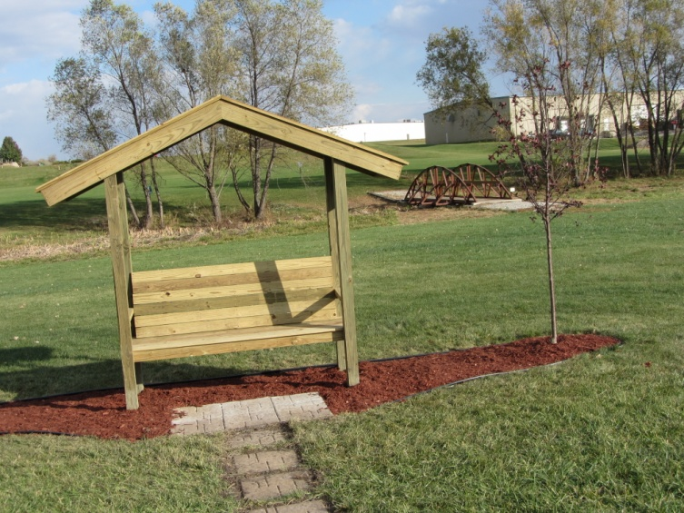
- All restrooms were closed this week.
- The mower we purchased has a mulcher on it so that has been used to on the leaves in the parks.
- The adopt a flower bed, right of way areas, and landscape around facilites have been deadheaded for winter.

RECREATION UPDATE

SPECIAL NEEDS MOVIE NIGHT

This event took place on Thursday October 27th in the Hiawatha Community Center. This event is sponsored by the Parks Department and Barbers Etc. This time the movie was How to Train Your Dragon and there were about 10-15 people from the special needs population in attendance. Barbers Etc. is considering going another route for their special needs events for the 2012 year due to low attendance and the fact a movie night may not be the most suitable event for this type of audience. There is a Special Needs Dance scheduled for November 11th in the Community Center. This event is very popular and will continue for the 2012 calendar year.

